CITI Conflicts of Interest Module Instructions

- Go to the CITI website
- If you are not registered with CITI, click the white “Register” button, and proceed with the registration process. Select “University of North Carolina at Greensboro” as your organization affiliation and enter all required name/address information.

NOTE: UNCG now uses Single Sign-On. This means you can log-in/register using your UNCG credentials, and you will not need a separate CITI username and password.

- For single sign on (SSO): Click “Log In” and then "Log In Through My Organization”. Search for “University of North Carolina at Greensboro”, and login using your UNCG credentials.
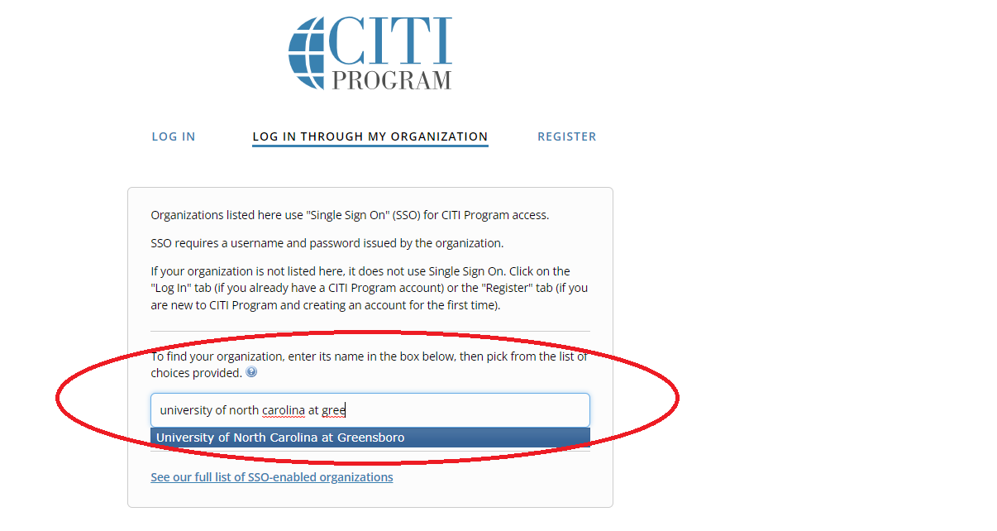

- Once logged in, click “My Courses”, then click “View Courses” next to University of North Carolina at Greensboro

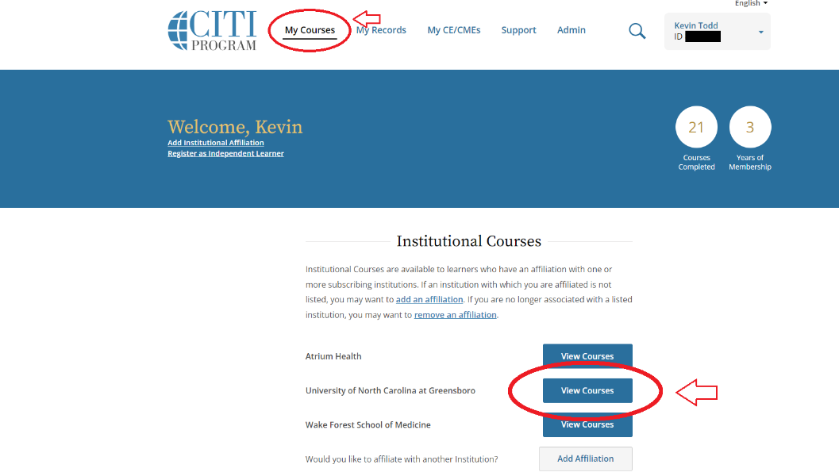

- Once on the courses page, click “Add a Course” at the bottom of the page.
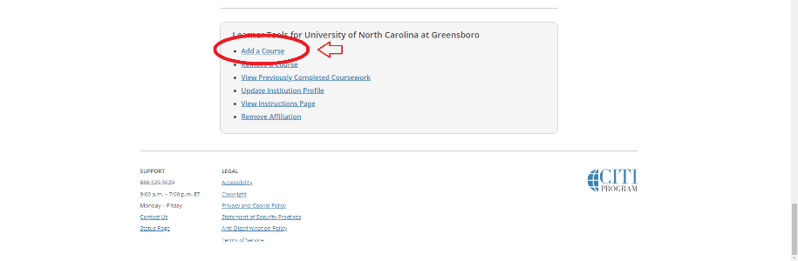
- Click “Responsible Conduct of Research (RCR)”, then the “Next” button
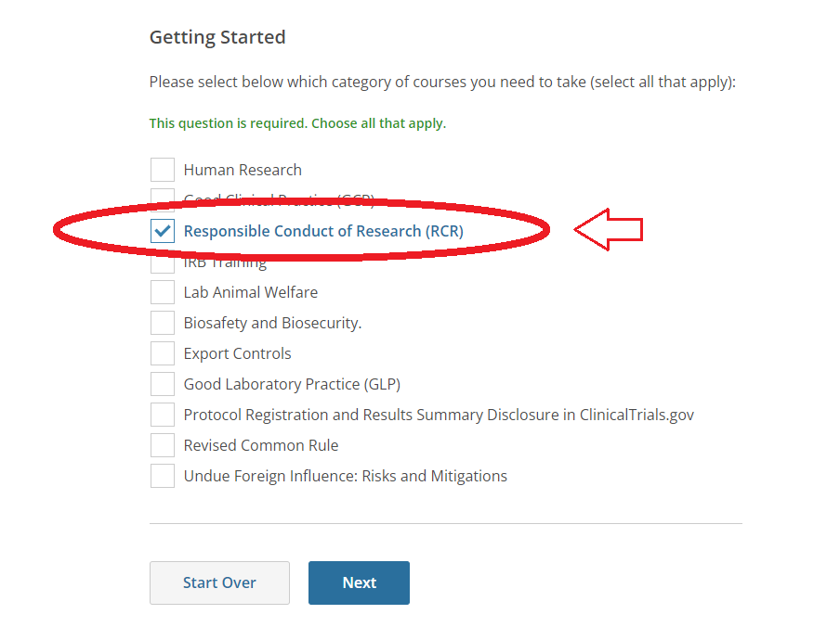
- Click “Conflicts of Interest (COI)”, then the “Next” button
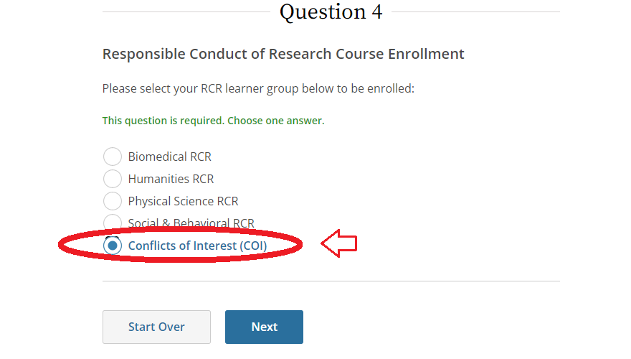

- You will see the “Conflicts of Interest” course loaded under “Courses Ready to Begin”
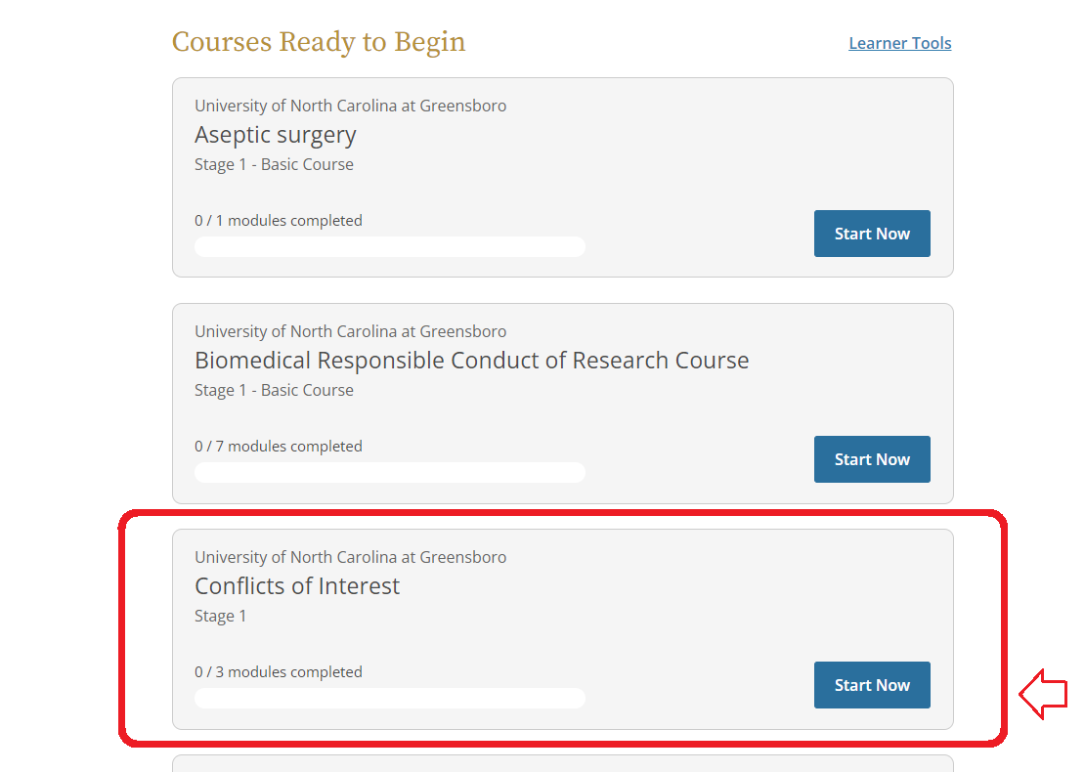

- If you already created a CITI account before coming to UNCG, you will need to affiliate your account with our institution: Once logged in, go to the “My Courses” tab. Click Add Institutional Affiliation”. On the next page, search for “University of North Carolina at Greensboro”, then select “Next”.

  - If you would like to receive credit for modules previously taken, there are several requirements that must be met:

- To transfer course credit between institutions, you will need to be affiliated with both institutions (your previous institution and your new institution). Follow the steps above to add affiliates.
- When you are affiliated with both institutions, enroll in the courses that need to be transferred under both institutions, via the "Add a Course or Update Learner Groups" link under the appropriate institution if necessary. You will need to enroll in the same stage of the course (Basic / Refresher) for a proper transfer to occur.
- Once you are enrolled in the courses, any modules that are shared between the courses between institutions will have their credit transferred automatically. The transfer is based on each module's unique ID number. If the courses do not match exactly, not all credit will transfer and you may need complete the difference in modules at your new institution to get full credit for a Completion Report.
- Each institution determines the time frame in which modules are transferable. This time frame can span any time between 1 and 10 years. Some institutions opt out of this option and do not allow modules to transfer.

